**VISVESVARAYA TECHNOLOGICAL UNIVERSITY**

**“Jnana Sangama”, Belagavi-590018, Karnataka**



***A Mini Python Project Report on***

**“age calculator using python”**

***Submitted in partial fulfilment of the requirement for the award of degree of***

**Bachelor of Engineering**

In

**Computer Science and Engineering**

***Submitted by***

**MOHAMMAD USMAN SHARIF**

**(4NN17CS402)**

**PAVAN P**

**(4NN17CS403)**

Under the Guidance of

**Mr. Raghavendra.K**

**Assistant Professor**

**Dept. of CS & Engineering**



**Department of Computer Science and Engineering**

**NIE Institute of Technology**

**Mysuru -570018**

**2019-20**

**Department of Computer Science and Engineering**

**NIE Institute of Technology**



***CERTIFICATE***

This is to certify that the mini project entitled ***“AGE CALCULATOR”*** is carried out by ***MOHAMMAD USMAN SHARIF*** and ***PAVAN P*** bearing**USN:*4NN17CS402, 4NN17CS403*** respectivelyin the partial fulfilment for theSixth semester of **Bachelor of Engineering degree** in **Computer Science and Engineering** of the **Visvesvaraya Technological University, Belagavi** during the academic year **2019-20**. The project report has been approved as it satisfies the academic requirements with respect to project work prescribed for the Bachelor of Engineering.

|  |  |
| --- | --- |
| **Signature of the Guide** | **Signature of the HOD** |
| **Mr. Raghavendra K.** | **Smt. Vedavathi N** |
| Assistant Professor, | Assistant Professor & HOD, |
| Dept. of CS & Engineering | Dept. of CS & Engineering |
| NIEIT, Mysuru | NIEIT, Mysuru |

**External Viva**

**Name of the examiners**

**Signature with Date**

**1**……………………....

**1**……………………….

**2**……………………….

**2** ………………………

**ACKNOWLEDGEMENT**

The satisfaction and euphoria that accompany the successful completion of any task would be incomplete without the mention of the people who made it possible, whose consistent guidance and encouragement crowned our efforts with success.

We consider ourselves proud to be a part of **NIE Institute of Technology Mysuru** family, the institution which stood by our side in all our endeavours.

We wish to express our gratitude to [**Prof. Bansilal,**](http://www.nieit.ac.in/images/eeepdf/APN.pdf) Principal, **NIE Institute** **of Technology Mysuru,** for providing a congenial working environment.

We express our sincere thanks to **Smt. Vedavathi N**, Assistant Professor and HOD, Department of Computer Science and Engineering, for her support and encouragement.

We would like to thank our guide**, Mr. Raghavendra K.** Assistant Professor, Department of Computer Science and Engineering, for his inspiration, guidance, constant supervision, direction and discussions in the successful completion of this project work.

We are thankful to the Department of Computer Science and Engineering staff members and non-staff members for their co-operation extended towards this work.

Finally, our heartfelt gratitude to our **family members, relatives** and **friends** for their constant support, motivation and encouragement throughout this project. Above all we would like to thank God Almighty, for having showered his blessings on us.

**Mohammad Usman Sharif (4NN17CS402)**

**Pavan p (4NN17CS403)**

**TABLE OF CONTENT**

**Sl. No Particulars Page No**

1 About Project 1

2 System Requirements 2

3 Source Code 3

4 Screenshots 9

5 References 11

1. **About Project**

Python offers multiple options for developing a GUI (Graphical User Interface). Out of all the GUI methods, tkinter is the most commonly used method. It is a standard Python interface to the Tk GUI toolkit shipped with Python. Python with tkinter outputs the fastest and easiest way to create GUI applications. Now, it’s up to the imagination or necessity of a developer, what he/she wants to develop using this toolkit.

The age of a person can be counted differently in different cultures. This calculator is based on the most common age system. In this system, age grows at the birthday. For example, the age of a person that has lived for 3 years and 11 months is 3 and the age will turn to 4 at his/her next birthday one month later. Most western countries use this age system.

In some cultures, age is expressed by counting years with or without including the current year. For example, one person is twenty years old is the same as one person is in the twenty-first year of his/her life. In one of the traditional Chinese age systems, people are born at age 1 and the age grows up at the Traditional Chinese New Year instead of birthday. For example, if one baby was born just one day before the Traditional Chinese New Year, 2 days later the baby will be at age 2 even though he/she is only 2 days old.

In some situations, the months and days result of this age calculator may be confusing, especially when the starting date is the end of a month. For example, we all count Feb. 20 to March 20 to be one month. However, there are two ways to calculate the age from Feb. 28, 2015 to Mar. 31, 2015. If thinking Feb. 28 to Mar. 28 as one month, then the result is one month and 3 days. If thinking both Feb. 28 and Mar. 31 as the end of the month, then the result is one month. Both calculation results are reasonable. Similar situations exist for dates like Apr. 30 to May 31, May 30 to June 30, etc. The confusion comes from the uneven number of days in different months. In our calculation, we used the former method.

**2. SYSTEM REQUIREMENTS**

### HARDWARE REQUIREMENTS

* + - Microprocessor: 1.0 GHz and above CPU INTEL Microprocessor Architecture
    - Main memory: 1 GB RAM
    - Hard Disk: 10 GB
    - Keyboard: QWERTY Keyboard
    - Monitor: 1024 x 768 display resolution

### SOFTWARE REQUIREMENTS

* + - Programming language: Python
    - Operating system: Windows 8.1 Pro
    - Compiler/IDE: Python 3.8 64bit
    - Project type: Desktop Application.

**3. SOURCE CODE**

**from tkinter import \***

**from tkinter import messagebox**

**from tkinter import ttk**

**from datetime import date**

**def clearAll() :**

**dayField.delete(0, END)**

**monthField.delete(0, END)**

**yearField.delete(0, END)**

**givenDayField.delete(0, END)**

**givenMonthField.delete(0, END)**

**givenYearField.delete(0, END)**

**rsltDayField.delete(0, END)**

**rsltMonthField.delete(0, END)**

**rsltYearField.delete(0, END)**

**def checkError() :**

**if (dayField.get() == "" or monthField.get() == ""**

**or yearField.get() == "" or givenDayField.get() == ""**

**or givenMonthField.get() == "" or givenYearField.get() == "") :**

**messagebox.showerror("Input Error")**

**clearAll()**

**return -1**

**def calculateAge():**

**value = checkError()**

**if value==-1:**

**return**

**else:**

**birth_day = int(dayField.get())**

**birth_month = int(monthField.get())**

**birth_year = int(yearField.get())**

**given_day = int(givenDayField.get())**

**given_month = int(givenMonthField.get())**

**given_year = int(givenYearField.get())**

**month =[31, 28, 31, 30, 31, 30, 31, 31, 30, 31, 30, 31]**

**if (birth_day > given_day):**

**given_month = given_month - 1**

**given_day = given_day + month[birth_month-1]**

**if (birth_month > given_month):**

**given_year = given_year - 1**

**given_month = given_month + 12**

**calculated_day = given_day - birth_day;**

**calculated_month = given_month - birth_month;**

**calculated_year = given_year - birth_year;**

**rsltDayField.insert(10, str(calculated_day))**

**rsltMonthField.insert(10, str(calculated_month))**

**rsltYearField.insert(10, str(calculated_year))**

**if __name__ == '__main__':**

**root = Tk()**

**root.config(background='violet')**

**root.title('Age Calculator')**

**root.geometry('530x300')**

**dob = Label(root, bg = 'sky blue')**

**givenDate = Label(root, text='Given Date', bg = 'sky blue')**

**birthDate = Label(root, text='Birth Date', bg = 'sky blue')**

**day = Label(root, text = 'Day', bg = 'violet')**

**month = Label(root, text = 'Month', bg = 'violet')**

**year = Label(root, text = 'Year', bg = 'violet')**

**givenDay = Label(root, text = "Given Day", bg = "violet")**

**givenMonth = Label(root, text = "Given Month", bg = "violet")**

**givenYear = Label(root, text = "Given Year", bg = "violet")**

**rsltYear = Label(root, text = "Years", bg = "violet")**

**rsltMonth = Label(root, text = "Month", bg = "violet")**

**rsltDay = Label(root, text = "Days", bg = "violet")**

**dayField = Entry(root)**

**monthField = Entry(root)**

**yearField = Entry(root)**

**givenDayField = Entry(root)**

**givenMonthField = Entry(root)**

**givenYearField = Entry(root)**

**rsltYearField = Entry(root)**

**rsltMonthField = Entry(root)**

**rsltDayField = Entry(root)**

**resultantAge = Button(root, text = "Resultant Age", fg = "Black", bg = "green", command = calculateAge)**

**clearAllEntry = Button(root, text = "Clear All Output", fg = 'Black', bg = 'Purple', command = clearAll)**

**usm = Label (root, text = "project by", fg = 'Black', bg = "violet")**

**usa = Label (root, text = "MD.Usman Sharif And Pavan P", fg = 'Black', bg = "violet")**

**dob.grid(row = 0, column = 1)**

**day.grid(row = 1, column = 0)**

**dayField.grid(row = 1, column = 1)**

**month.grid(row = 2, column = 0)**

**monthField.grid(row = 2, column = 1)**

**year.grid(row = 3, column = 0)**

**yearField.grid(row = 3, column = 1)**

**givenDate.grid(row = 0, column = 4)**

**birthDate.grid(row = 0, column = 1)**

**givenDay.grid(row = 1, column = 3)**

**givenDayField.grid(row = 1, column = 4)**

**givenMonth.grid(row = 2, column = 3)**

**givenMonthField.grid(row = 2, column = 4)**

**givenYear.grid(row = 3, column = 3)**

**givenYearField.grid(row = 3, column = 4)**

**resultantAge.grid(row = 4, column = 2)**

**rsltYear.grid(row = 5, column = 2)**

**rsltYearField.grid(row = 6, column = 2)**

**rsltMonth.grid(row = 7, column = 2)**

**rsltMonthField.grid(row = 8, column = 2)**

**rsltDay.grid(row = 9, column = 2)**

**rsltDayField.grid(row = 10, column = 2)**

**clearAllEntry.grid(row = 12, column = 2)**

**usm.grid(row = 13, column = 4)**

**usa.grid(row = 14, column = 4)**

**root.mainloop()**

**4. SCREENSHOTS**

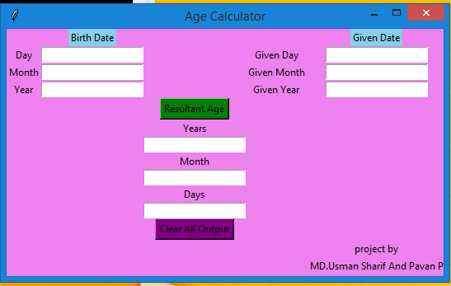

**Fig: 4.1 Initial screen of the project**

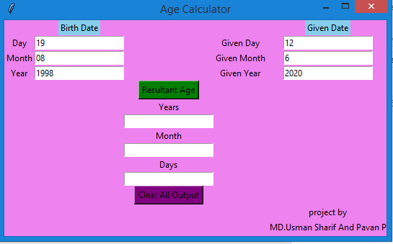

**Fig :4.2 Screen with values entered**

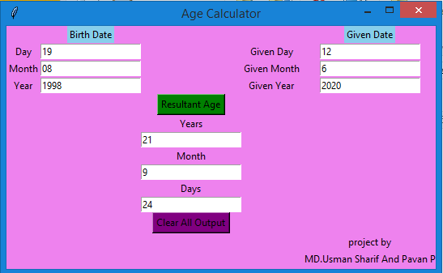

**Fig:4.3 The output screen for values entered**

**5. REFERENCES**

1. Stack overflow
2. [www.python.org](http://www.python.org)
3. [Python Crash Course, 2nd Edition: A Hands-On, Project-Based Introduction to Programming](https://geni.us/940d)
4. [Python Machine Learning: Machine Learning and Deep Learning with Python, scikit-learn, and TensorFlow](http://geni.us/9BUn)